**Assignment -01**

Microprocessor and Interfacing Sessional (CSE 3812)

**Q1**: The user will input 3 numbers (single digit) and the program will output the second highest number. The sample input and output is given below:

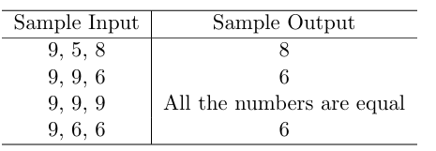

**Q2**: Write an assembly language code to derive the final value of the number sequence: -1+2-3+4-5+…..N. (Using Loop). Take the input value of N (in between 2 to 9) as a single ASCII character and then adjust it to the actual decimal value in your program. Finally, store the output in a variable named RESULT. You do not need to display the output in the console

**Q3**: First of all we will input a mark of the subject from the candidate and according to the following condition we will calculate the grade.

1. If marks <50 then Grade is F
2. if marks >=50 and marks <60 then Grade is D
3. if marks >=60 and marks <70 then Grade is C
4. if marks >=70 and marks <80 then Grade is B
5. if marks >=80 and marks <90 then Grade is A
6. if marks >=90 then Grade is A+

For taking input of multi-digit from the user, you may use the following code. First, define a variable named ‘N’ in the data segment.

| ; fast BX = 0  XOR BX, BX    INPUT_LOOP:  ; char input  MOV AH, 1  INT 21H  ; if \n\r, stop taking input  CMP AL, CR  JE END_INPUT_LOOP  CMP AL, LF  JE END_INPUT_LOOP | ; fast char to digit  ; also clears AH  AND AX, 000FH  ; save AX  MOV CX, AX    ; BX = BX * 10 + AX  MOV AX, 10  MUL BX  ADD AX, CX  MOV BX, AX  JMP INPUT_LOOP    END_INPUT_LOOP:  MOV N, BX |
| --- | --- |
| **Sample Input:** 80  **Ouput**: Grade: A | **Sample Input**: 45  **Ouput:** Grade: F |

**Submission Deadline**: 23 November 2024 (11:59 pm)

* While you are encouraged to talk to your peers and search relevant resources online, under no circumstances should you copy code from any source. If found out, you will receive zero marks.